
SRM Institute of Science and Technology
Mode of Exam
OFFLINE
College of Engineering and Technology
School of Computing
DEPARTMENT OF COMPUTING TECHNOLOGIES
SRM Nagar, Kattankulathur – 603203, Chengalpattu District, Tamilnadu
Academic Year: 2022-2023 (ODD)
Test: CLAT-1 Date: 22.02.2023
Course Code & Title: 18CSC305J– Artificial Intelligence Duration: 9.45 am– 10.45 am
Year & Sem: III/VI Max. Marks: 25

Course Articulation Matrix:
CO | PO1 | PO2 | PO3 | PO4 | PO5 | PO6 | PO7 | PO8 | PO9 | PO10 | PO11 | PO12
CO1 | M | M | M | M | H | - | - | - | M | L | - | H
CO2 | M | H | H | H | H | - | - | - | M | L | - | H
CO3 | M | H | H | M | H | - | - | - | M | L | - | H
CO4 | M | H | M | H | H | - | - | - | M | L | - | H
CO5 | M | H | H | H | H | - | - | - | M | L | - | H
CO6 | L | H | M | M | H | - | - | - | H | L | - | H

Part - A
( 10 x 1 = Marks)
Instructions: Answer all
Q. No | Question | Marks | BL | CO | PO | PI Code
1 | Which is not an example of ill-structured problem  - Predicting how to dispose e-waste safely  - Security threats in social gatherings  - Network flow analysis problem  - Predicting how to throw the waste in the dustbin  Ans: c | 1 | 1 | 1 | 1 | 1.6.1
2 | State artificial intelligence  - Programming with your intelligence  - Feeding your intelligence into computers  - Game playing  - Enable computers to be intelligent  Ans: d | 1 | 1 | 1 | 1 | 1.6.1
3 | Select the field that investigates high level human/animal thinking  - Psychology and cognitive science  - Philosophy  - Neuroscience  - Linguistics  Ans: a) | 1 | 2 | 1 | 1 | 1.6.1
4 | _________ is used by the agent to act upon the environment  - Sensors  - Actuators  - Perceptors  - Motors  Ans: b) | 1 | 1 | 1 | 1 | 1.6.1
5 | Analyze the role of knowledge in playing chess  - To able to recognize solution  - To Constrain the search for a solution  - To able to recognize solution and to Constrain the search for a solution  - To reach the goal state with single path cost.  Ans: b | 1 | 2 | 1 | 1 | 1.6.1
6 | Identify the problem type which is very hard to formulate and ambiguous in nature.  - Structured  - Linear  - Unstructured  - Non- Linear  Ans: c | 1 | 2 | 1 | 1 | 1.6.1
7 | Solve the crypt arithmetic puzzle LET + LEE = ALL  - L=5, T=2, A=5, E=1  - T=5, A=2, L=1, E=4  - E=3, A=1, T=5, L=6  - L=1 ,E=5, T=6, A=3  Ans: d | 1 | 3 | 1 | 2 | 1.6.1
8 | Which type of agents does personal assistants like siri, Alexa belongs to  - Intelligent agents  - Simple reflex agents  - Model-based agent  - Problem-solving agent  Ans: a) | 1 | 2 | 1 | 2 | 1.6.1
9 | _________________ are mathematical problems defined as a set of objects whose state must satisfy a number of constraints or limitations.  a) Constraints Satisfaction Problems  b) Uninformed Search Problems  c) Local Search Problems  d) Component based problem  Ans: a) | 1 | 1 | 1 | 1 | 1.6.1
10 | Intelligent backtracking makes use of  a. Unassigned variables set to decide the values  b. A conflict set to backtrack to the source  c. Backjumping to detect the failure node  d. Heuristic to detect the failure  Ans: c | 1 | 1 | 1 | 1 | 1.6.1
Part – B
( 3 x 5 = Marks)
Instructions: Answer any 3
11 | Expand PEAS. Give PEAS description for online elective polling system.  PEAS stands for Performance measures, Environment, Actuators, and Sensors.  Performance measures: These are the parameters used to measure the performance of the agent. How well the agent is carrying out a particular assigned task.  Environment: It is the task environment of the agent. The agent interacts with its environment. It takes perceptual input from the environment and acts on the environment using actuators.  Actuators: These are the means of performing calculated actions on the environment. For a human agent; hands and legs are the actuators.  Sensors: These are the means of taking the input from the environment. For a human agent; ears, eyes, and nose are the sensors.  Performance measures:  Cost of the portal  Quality of the portal system  Time taken to poll  Environment:  Portal page components which has the details such as Time slot, Date, Day order, Lab venue etc.  Actuators:  Booking function, Pc, Mobile device  Sensors  Input and output device  Eyes | 5 | 3 | 1 | 2 | 1.6.1
12 | You are given two jugs, a 5-gallon one and a 3-gallon one, a pump which has unlimited water which you can use to fill the jug, and the ground on which water may be poured. Neither jug has any measuring markings on it. How can you get exactly 1 gallons of water in the 5-gallon jug?  Represent the solution with state space.  Solution:  initial state: (5,3)  goal state: (1,0)  operators:  i) empty big(remove water from big jug)  ii) empty small(remove water from small jug)  iii) big is empty(pour water from small jug to big jug)  iv) small is empty(pour water from big jug to small jug)  actions of sequence: 2,4,2,4,2 | 5 | 3 | 1 | 2 | 1.6.1
13 | Describe the utility based agent with example.  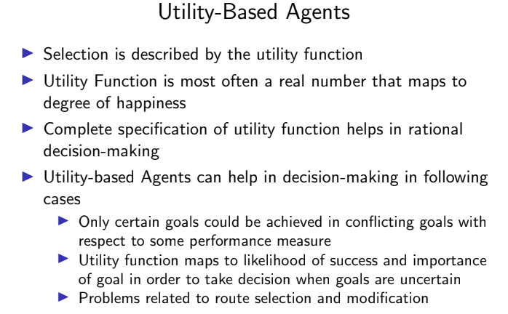  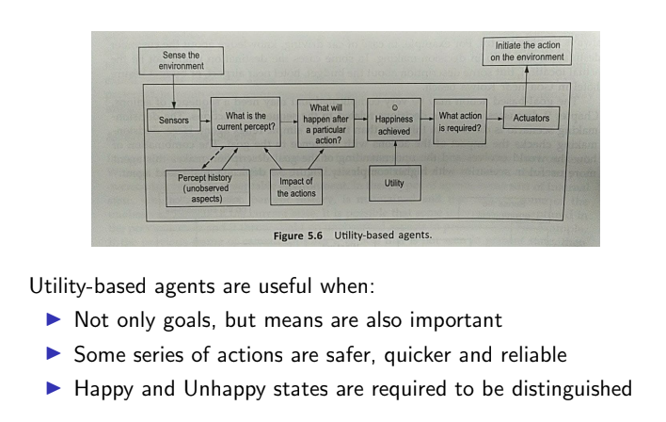 | 5 | 1 | 1 | 1 | 1.6.1
14 | Compare forward checking and constraint propagation.  Forward checking • Idea: – Keep track of remaining legal values for unassigned variables – Terminate search when any variable has no legal values  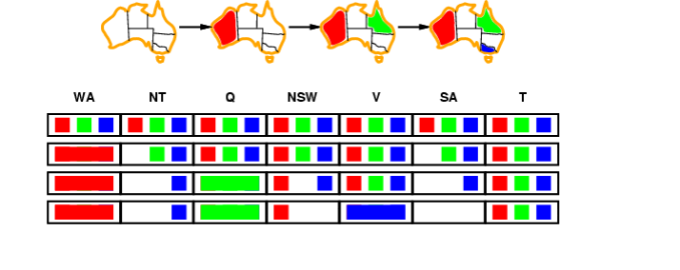  Constraint propagation  • Forward checking propagates information from assigned to unassigned variables, but doesn't provide early detection for all failures:  NT and SA cannot both be blue!  • Constraint propagation algorithms repeatedly enforce constraints locally…  Arc consistency • Simplest form of propagation makes each arc consistent • X → Y is consistent iff for every value x of X there is some allowed y  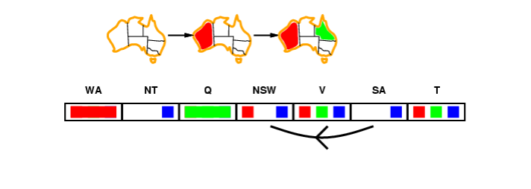 | 5 | 2 | 1 | 1 | 1.6.1

*Performance Indicators are available separately for Computer Science and Engineering in AICTE examination reforms policy.

Course Outcome (CO) and Bloom’s level (BL) Coverage in Questions

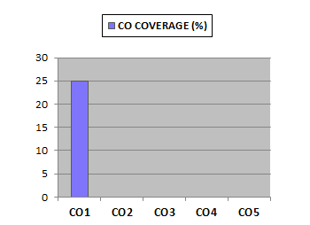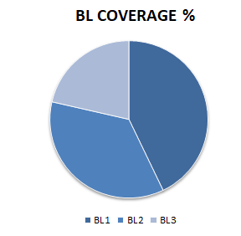

Approved by the Audit Professor/Course Coordinator

